UNNATI COMPUTER EDUCATION
BATCH YEAR : 2026

PROJECT ON C-LANGUAGE
SUBJECT: PETROL PUMP BILL GENERATION

SUBMITTED BY:
NANDINI S VALASANGAD

DIRECTOR SIGN CLASS INCHARGE SIGN

PARENTS SIGN
ABSTRACT
Petrol Pump Bill Generator is a mini project developed using C programming language. The main purpose of this project is to automate the billing process at petrol pump. It helps in generating accurate bills for customers after fuel filling. The software stores customer details such as customer name, vehicle number and mobile number. It allows the user to select the fuel type, choose the nozzle and enter quantity of fuel filled.

The project automatically calculates the total bill based on the fuel price per litre and displays the remaining fuel available in storage tank after each transaction. It also maintains the total litres of fuel dispensed through each nozzle, making it easier to monitor fuel usage. This system reduces manual calculation errors, saves time and improves efficiency of petrol pump operations. The project demonstrates the practical application of C programming concepts such as variables, loops, conditional statements, arrays and user-defined logic.
Introduction to C-Language:
C is powerful, general purpose programming in the early 1970’s by Dennis Ritchei at bell labs. It is widely used for system programming operating system, embedded system and application software.
Features of C-Language:
- Simple and efficient: Easy to learn, yet powerful.
- Structured language: Encourages modular programming through function.
- Low-level Access: Can interact directly with memory using pointer.
- Portable: Code written in C can run on different machines with little or no modifications.
Explanation:
- #include<stdio.h>-include the standard input or output library.
- Main()-The entry point of every C programming.
- Printf()-Function to print text on the screen.
- Return 0-Indicates successful program termination.

INTRODUCTION
C-LANGUAGE PETROLPUMP BILL SYSTEM
A petrol pump is service station where fuel such as petrol and diesel is supplied to vehicles. Managing customer details, calculating bills, and tracking fuel usage are important activities at a petrol pump. Performing these tasks manually can take more time and may result in calculation errors.

The petrol pump bill generator is mini project developed using C programming language to simplify and automate billing process. This helps reduce manual work, save time, and improve accuracy.

The project demonstrates the practical use of C programming language concepts such as variables, input or output functions, conditional statements, loops, and arithmetic operations. It provides a simple and user-friendly approach to petrol pump billing and fuel monitoring.

PRESENT SYSTEM:
In the present system, the billing process in many small petrol pump is carried out manually. Customer details, fuel quantity, and bill calculations are written in registers or calculated using simple calculators. This method consumes more time and increases the possibility of human errors in billing and record maintenance. It is also difficult to monitor the fuel remaining in the tank and the amount of fuel dispensed through each nozzle. Maintaining records manually becomes inconvenient as the number of customers increases.

PROPOSED SYSTEM:
The proposed system is Petrol Pump Bill Generator developed using C programming Language. It automates the billing process by accepting customer details, fuel type, nozzle selection, and fuel quantity. The system automatically calculates the total bill, updates remaining fuel in tank, maintains total litres of fuel dispensed through each nozzle. This reduces manual errors, svaes time, improves accuracy, and makes record management easier. The proposed system is simple, efficient, user-friendly and suitable for educational as well as small-scale petrol pump applications.
HARDWARE REQUIREMENTS:
- Processor: Intel Core i3 or above
- RAM: 4GB (Minimum)
- Hard Disk: 500 GB or above
- Monitor: LCD/LED Monitor
- Keyboard: Standard Keyboard
- Mouse: Optical Mouse

SOFTWARE REQUIREMENTS:
- Operating System: Windows 7/8/10/11
- Programming Language: C
- Compiler: Turbo C7/ GCC compiler
- Integrated Development Environment: Turbo C++, Code::Blocks, Dev-C++, or Visual Studio Code
- Text Editor: Notepad or Notepad++

SOURCE CODE :
#include<stdio.h>
#include<conio.h>
int main()
{
char customername[50];
char vehicleno[20];
char mobileno[15];
int fuelchoice,nozzle;
float quantity,priceperlitre,totalbill,tankcapacity,remainingfuel;
float petrolnozzle1=0,petrolnozzle2=0,petrolnozzle3=0;
float dieselnozzle1=0,dieselnozzle2=0,dieselnozzle3=0;
char choice;
clrscr();
printf("==========PETROL PUMP BILL GENERATION==========\n");
printf("enter total fuel available in tank(litres):");
scanf("%f",&tankcapacity);
remainingfuel=tankcapacity;
do
{
printf("\n--------------------------\n");
printf("enter customer name:");
scanf("%s",&customername);
printf("enter vehicle number:");
scanf("%s",&vehicleno);
printf("enter mobile number:");
scanf("%s",&mobileno);
printf("\nfuel type\n");
printf("1. petrol\n");
printf("2. diesel\n");
printf("enter choice:");
scanf("%d",&fuelchoice);
if(fuelchoice==1)
{
priceperlitre=102.50;
printf("\npetrol nozzle\n");
printf("1. petrol nozzle1\n");
printf("2. petrol nozzle2\n");
printf("3. petrol nozzle3\n");
}
else if(fuelchoice==2)
{
priceperlitre=91.80;
printf("\ndiesel nozzle\n");
printf("1. diesel nozzle1\n");
printf("2. diesel nozzle2\n");
printf("3. diesel nozzle3\n");
}
else
{
printf("invlaid fuel choice!\n");
continue;
}

printf("select nozzle:");
scanf("%d",&nozzle);
if(nozzle<1 || nozzle>3)
{
printf("invalid nozzle!\n");
continue;
}
printf("enter quantity(litres):");
scanf("%f",&quantity);
if(quantity>remainingfuel)
{
printf("\nonly %.2f litres available in tank.\n",remainingfuel);
continue;
}
totalbill=quantity*priceperlitre;
remainingfuel=remainingfuel-quantity;
if(fuelchoice==1)
{
if(nozzle==1)
petrolnozzle1 += quantity;
else if (nozzle==2)
petrolnozzle2 += quantity;
else
petrolnozzle3 += quantity;
}
else
{
if(nozzle==1)
dieselnozzle1 += quantity;
else if(nozzle==2)
dieselnozzle2 += quantity;
else
dieselnozzle3 += quantity;
}
printf("==========CUDSTOMER BILL==========\n");
printf("customer name:%s\n",customername);
printf("vehicle number:%s\n",vehicleno);
printf("mobile number:%s\n",mobileno);
if(fuelchoice==1)
{
printf("fuel type:petrol\n");
}
else
{
printf("fuel type:diesel\n");
}
printf("nozzle used:%d\n",nozzle);
printf("price/litre:Rs%.2f\n",priceperlitre);
printf("quantity:%.2flitres\n",quantity);
printf("total bill:Rs%.2f\n",totalbill);
printf("fuel remaining:%.2flitres\n",remainingfuel);
printf("=========================\n");
printf("\ndo you want to serve next customer? (Y/N):");
scanf(" %c",&choice);
} while(choice=='Y' || choice=='y');
// this section WILL print when choice is 'N' or 'n';
printf("==========PETROL PUMP REPORT==========\n");
printf("\npetrol nozzle report\n");
printf("nozzle 1: %.2f litres\n",petrolnozzle1);
printf("nozzle 2: %.2f litres\n",petrolnozzle2);
printf("nozzle 3: %.2f litres\n",petrolnozzle3);
printf("\ndiesel nozzle report\n");
printf("nozzle 1: %.2f litres\n",dieselnozzle1);
printf("nozzle 2: %.2f litres\n",dieselnozzle2);
printf("nozzle 3: %.2f litres\n",dieselnozzle3);
printf("\n-------------------------\n");
printf("total fuel remaining in tank:%.2flitres\n",remainingfuel);
printf("\n-------------------------\n");
printf("\nthank you!\n");
printf("visit again.\n");
getch(); //ADD THIS LINE HERE to pause the output screen!
return 0;
}

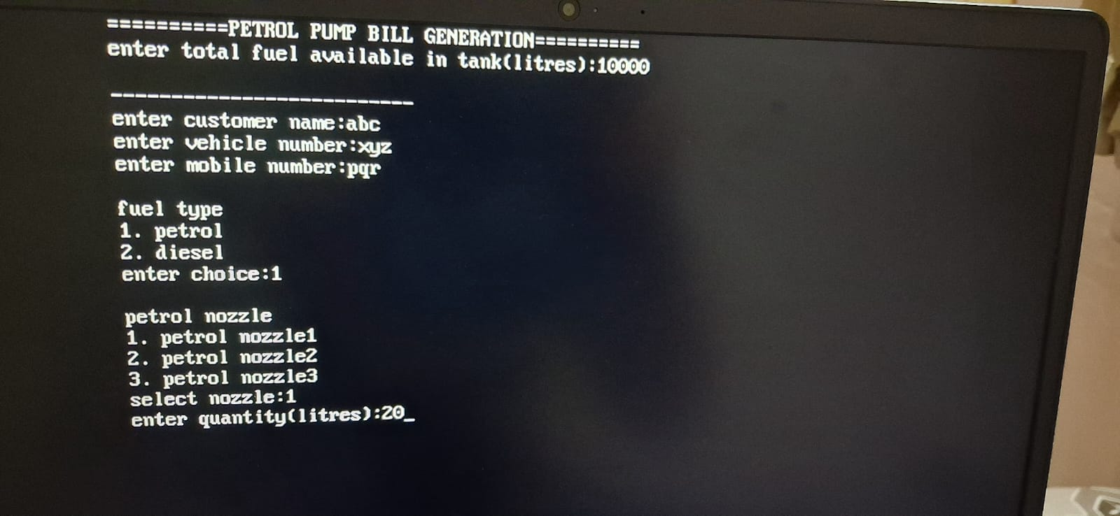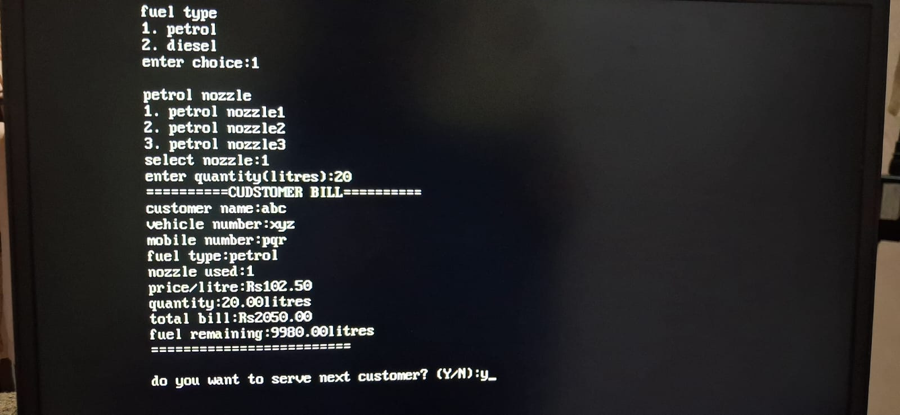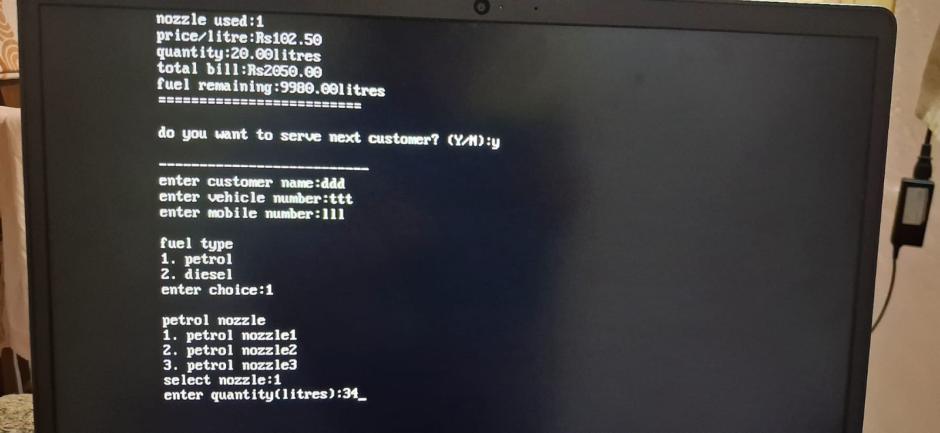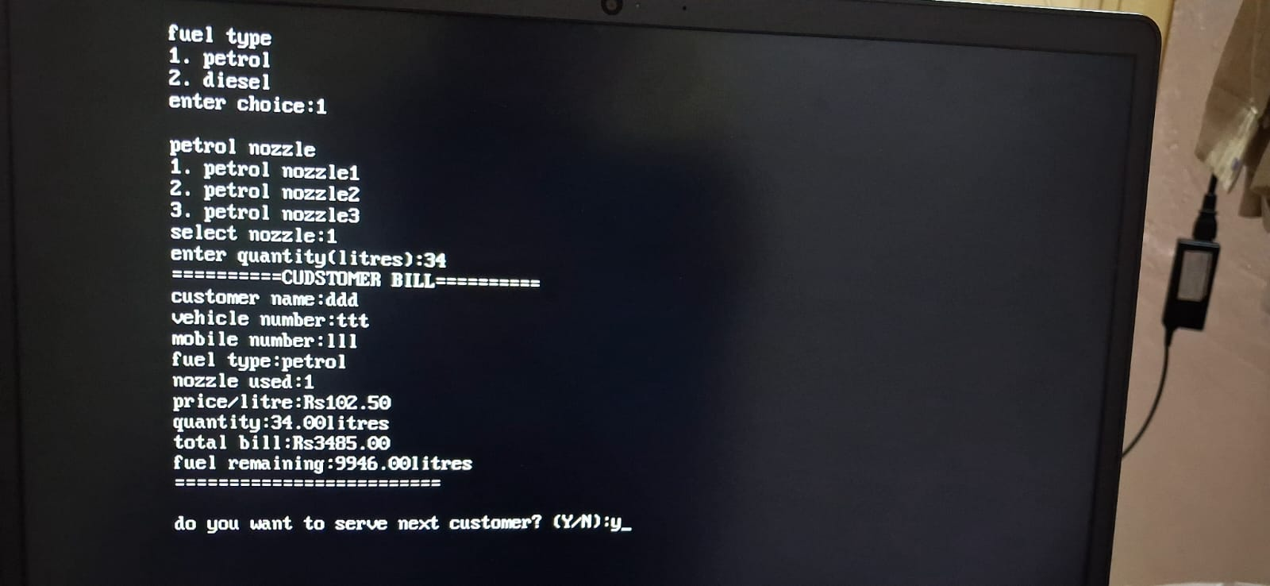

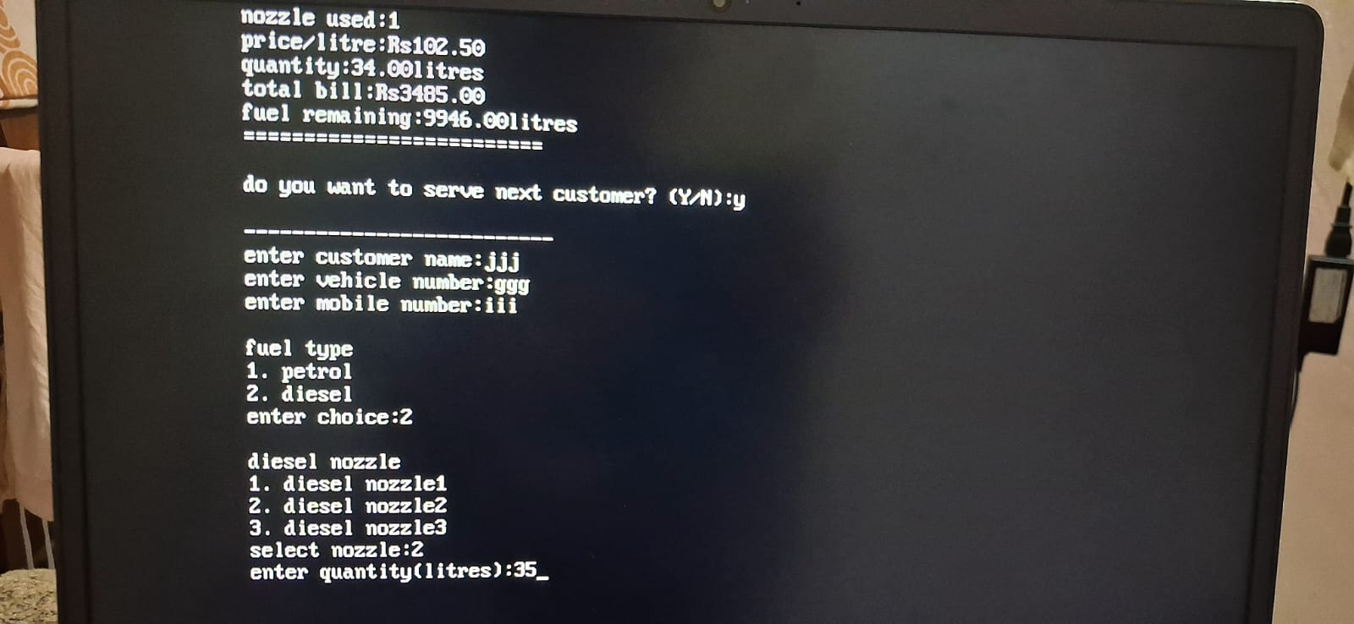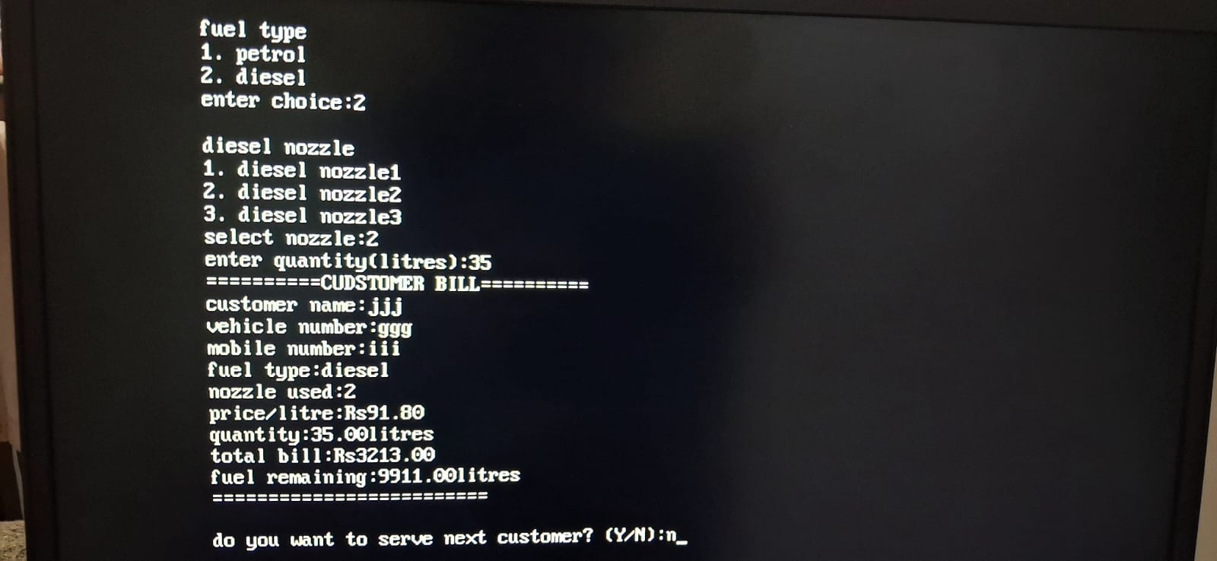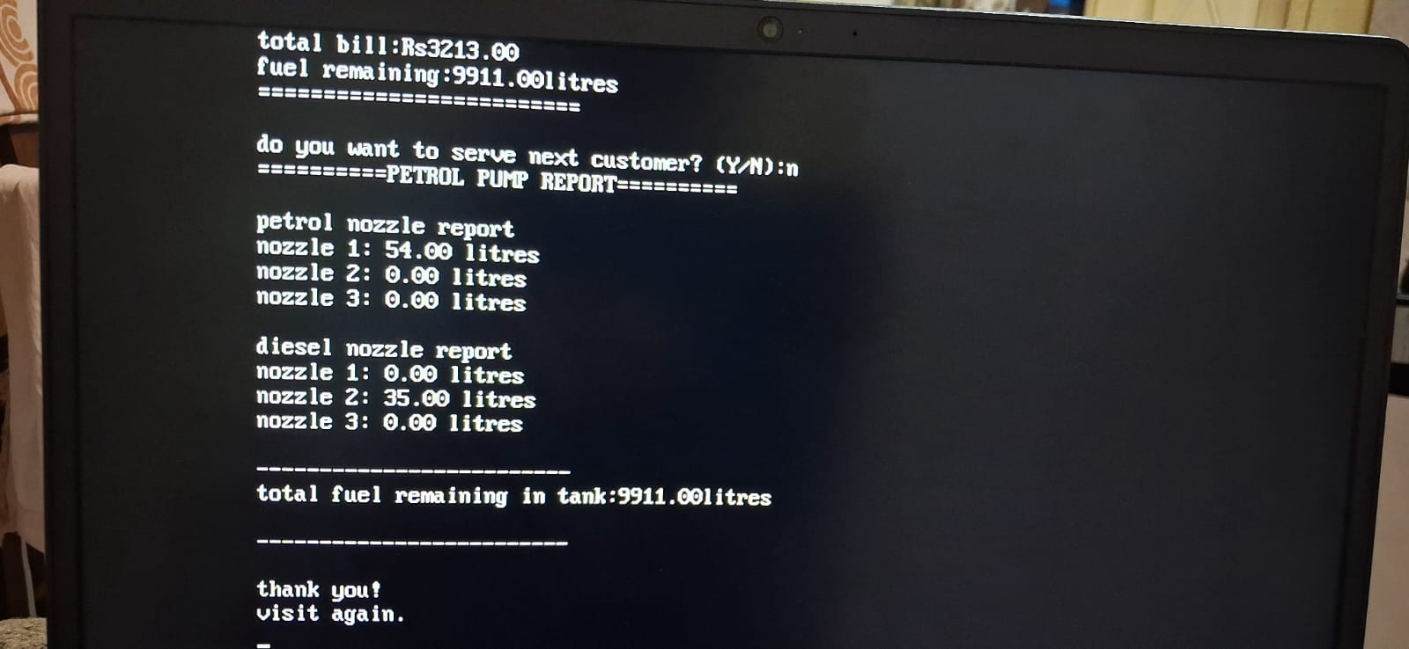

KEY ADVANTAGES OF THE PROJECT
1.Reduces Manual Work:
The system reduces the need for manual billing and record maintenance.
2.Accurate Bill Calculation:
It automatically calculates total bill based on quantity of fuel and price per litre, reducing calculation errors.
3.Saves Time:
Customer details and billing information can be processed quickly.
4.Customer Details Management:
The system records important details such as customer name, vehicle number and mobile number.
5.Nozzle-wise Fuel Tracking:
It records how many litres of fuel are dispensed through each petrol and diesel nozzle.
6.Tank Fuel Monitoring:
The system updates and displays the remaining fuel in the tank after every transaction.
7.Easy To Use:
The program has a simple input-based interface that is easy for the operator to understand.
8.Supports Multiple Customers:
The system can process billing for multiple customer continuously.
9.Reduces Human Errors:
Automatic calculations and fuel tracking help minimize mistakes in manual calculations.
10.Simple and Cost-Effective:
The project uses basic C programming concepts and does not require complicated or expensive software.
11.Useful For Learning:
It demonstrates practical applications of C concepts such as variables, conditional statements, loops, input/output functions, and arithmetic operations.

FEASIBILITY STUDY
The feasibility of the Petrol Pump Bill Generator was studied with reference to the requirements of a small petrol pump billing system. The project is feasible because it uses simple C programming concepts and requires only a basic computer system with a C compiler. It provides an easy method for generating customer bills, calculating fuel costs, monitoring the remaining fuel in the tank and maintaining nozzle-wise fuel usage.
The project is technically, economically, and operationally feasible and can be implemented easily for a small-scale petrol pump application.

REFERENCE:
- Standard C programming concepts and compiler documentation.
- UNNATI COMPUTER EDUCATION notes.
- LET US ‘C’ book reference.
- Chatgpt.
- Gemini.

CONCLUSION
The Petrol Pump Bill Generator is a simple and efficient project developed using the C programming language. It helps in generating customer bills by calculating the fuel cost based on the selected fuel type and quantity. The system also stores customer details, tracks the fuel remaining in the tank, and records the amount of fuel used through each nozzle.

The project reduces the manual calculations, saves time, and minimizes errors in billing. It demonstrates the practical application of basic C programming concepts such as variables, input/output, conditional statements, loops, and arithmetic operations. Overall, the project provides a simple and useful solution for managing petrol pump billing and fuel usage.

THANK YOU

UNNATI COMPUTER EDUCATION

